Jordan Conor Green: st10083222

Cameron Luke Pillay: st10083199

Daylin Shadrach: st10083296  
Mishra Mohammad: st10083182

OPSC7312 – PLANNING & DESIGN DOCUMENT

Varisty college durban north

2023

**Birdscape**

**TABLE OF CONTENTS**

1. **INTRODUCTION**
   1. Purpose of the Specification Document
2. **OVERVIEW**

2.1 Application: Name and Icon Design

2.2 Additional innovative features

1. **REQUIREMENTS**
   1. Document Requirements
   2. Additional innovative features
2. **USER INTERFACE DESIGN**
   1. Screen Mock-ups and Purpose
   2. Diagram – User Navigation
3. **DETAILED LISTING OF DATA**

5.1 Data Types

1. **PROJECT PLAN**

6.1 Gantt Chart

1. **CONCLUSION**

**REFERENCES**

**Introduction**

**BIRDWATCHING** refers to a relaxed pastime that allows individuals to appreciate the beauty of nature and to observe the distinctiveness of each species of birds documented in a safe manner, where no harm is done to our feathered-friends. This recreational activity is made more convenient as bird-admirers can install birdwatching apps on their cell phones so that they may discover species of birds that other enthusiasts have located nearby and the exact location. Admirers may be prompted to create their own bird listings to monitor their physical bird sightings, which will be based on their location or through image identification, and for enthusiasts to visualize a direct route to locate popular sighting hotspots through an integrate mapping (GPS) system. Birdscape is a birdwatching app that includes the above features and provides additional features and elements to make enthusiasts have the best experience as possible to view different species of birds.

**Overview**

Birdscape is the newest bird watching app that will allow enthusiasts of any experience to track and view various species of their choice. Our app was built to assist bird enthusiasts find local bird watching hotspots and provide directions to said spots. Users will also have the ability to save information they find interesting or important, information like a size, colour or an unusual bird species not native to the area.

**Birdscape logo**



**Innovative features:**

Prominent Bird News:

* A user-friendly feature that will be added to the Birdscape app that will show news feeds of relative birding news such as intriguing top news headline articles, bird extinctions, and additional bird fun facts and information.

Weather temperature:

* A comprehensive weather system will be included to give users more information on better days to go out.

**Requirements**

User Registration:

* The app must provide a feature that enables new users to register and create accounts. Users will be required to provide personal data such their email address and password.

User Login:

* The application must have a login feature that allows users to enter their registered email and password. Users will get access to the app's settings and tailored content after a successful authentication.

User Settings:

* Through settings, users should be able to personalize their app experience.

Nearby Hotspots Map:

* Users should be able to view hotspot locations by integrating this map directly into the app's user interface.

Filtering Hotspots:

* Based on the user's selected maximum travel distance, the hotspots that are shown on the map should be filtered.

User's Current Position:

* On the embedded map, the app should display the user's current location.

Getting Directions to Hotspot:

* Users ought to be able to choose a hotspot on the map and ask for directions to get there.

Route Calculation:

* Between the user's present location and the chosen hotspot, the app must determine the best route.

Visualizing Route:

* The app should visually display the suggested path on the embedded map when the route has been determined.

Recording Bird Observations:

* With the help of this tool, users can keep a record of their bird-watching activities, including the species, the date, and any further notes.

Viewing Bird Observations:

* Users of the app should have access to a list of all the bird observations they've stored.

Authentication Service:

* An online authentication service must securely retain registration data, including emails and passwords.

Hosted Database:

* An online, hosted database should be used to store user preferences and bird observations.

Displaying Bird Observations on Map:

* The location of user-recorded bird observations should be shown on a map by the app.

Prominent Bird News:

* Popular bird-related news articles and extra birding information will be displayed to the users. With this feature, we can educate our users about relative articles that responds to the most intriguing and most species of birds that they wish to view more research about.

Weather temperature:

* A thorough weather system will be included to give consumers additional knowledge about the best days to go outside.

**User Interface Design**

**Mock-up screens**

The **“Welcome”** screen depicts a greeting to the user with Birdscape’s logo and slogan and a button to ‘Get Started’ on bird-watching.

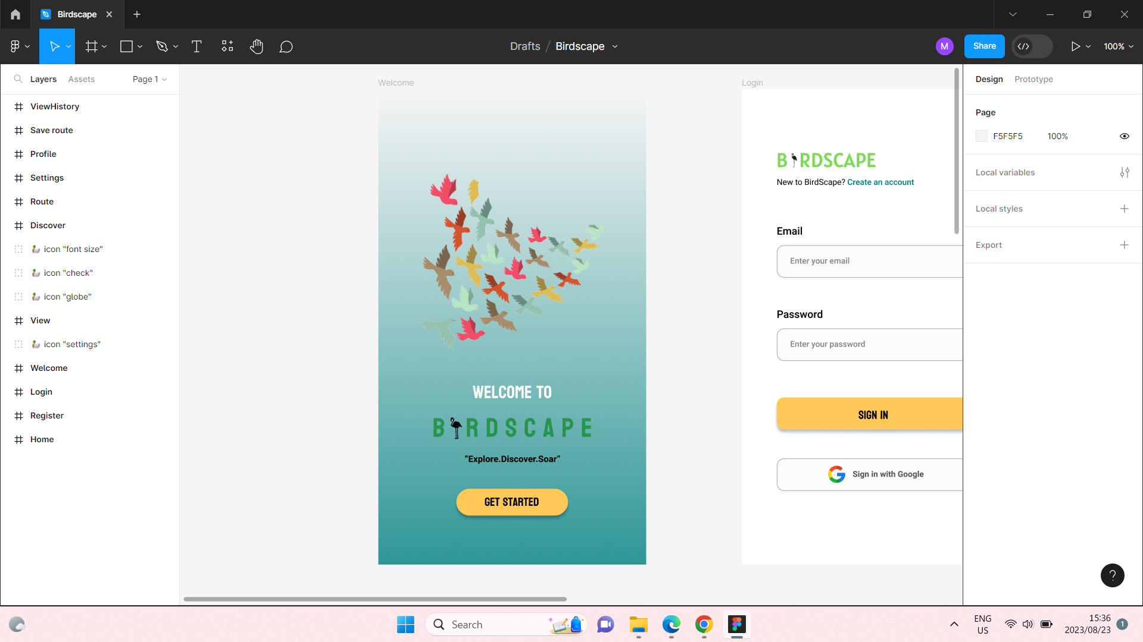

**Register**

The user may register an account on Birdscape by entering their email address and password or using their Google account.

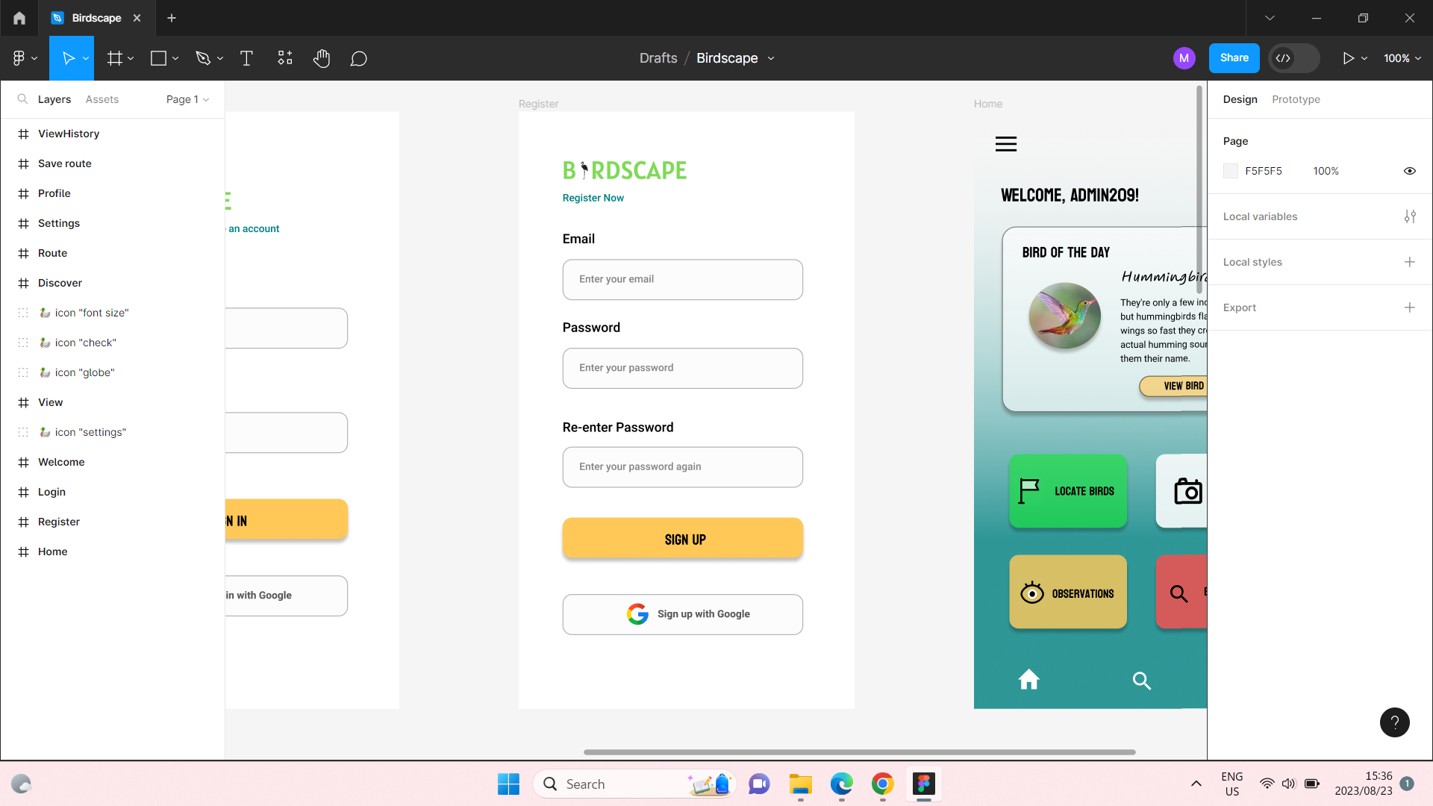

**Login**

User can login through their email or Google account.

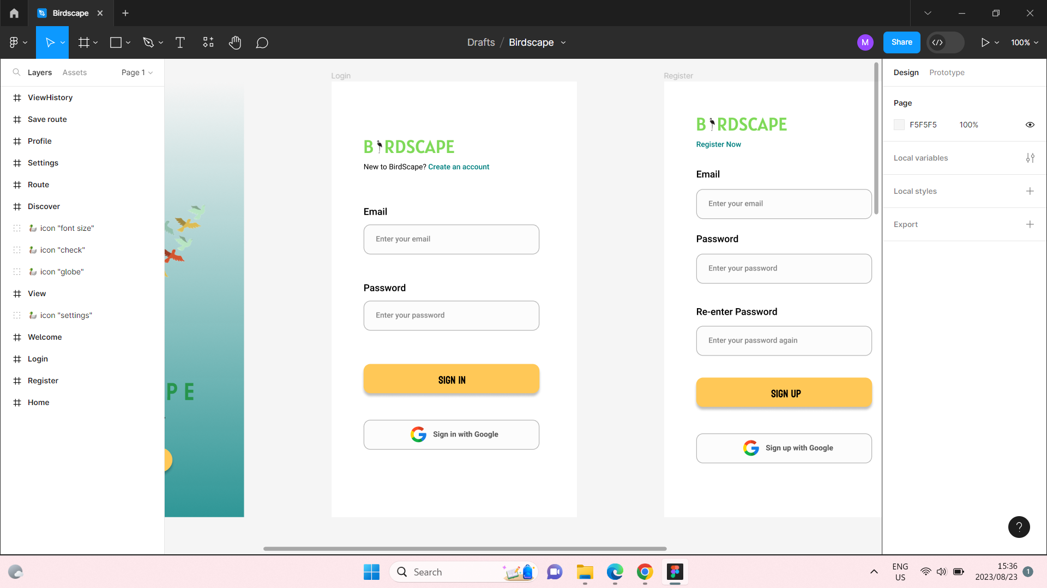

**Dashboard**

The dashboard depicts an extra feature of “Bird of the Day” to increase user knowledge, and each coloured-button takes you to the relevant screen. Another extra feature added is the weather component, at the top-right corner.

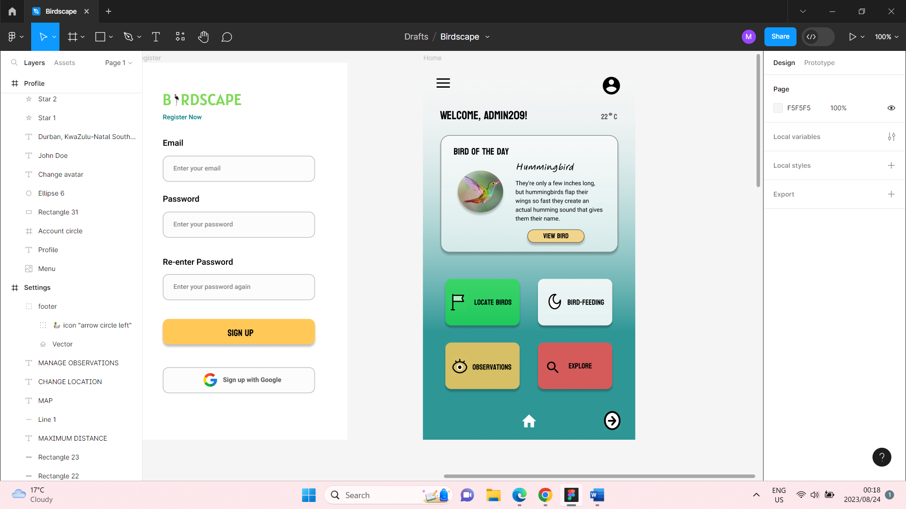

**Discover**

Depicts more information about “Bird of the Day” and facts. User may discover more birds by clicking the “DISCOVER” button or navigate to next screen.

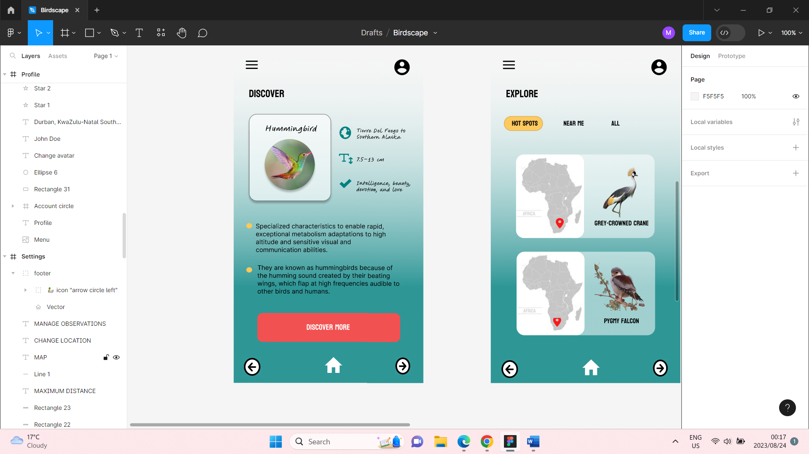

**Explore**

The “Explore” screen allows users to view more birds at various locations. Click on a bird to view the bird’s location or navigate back, in the footer.

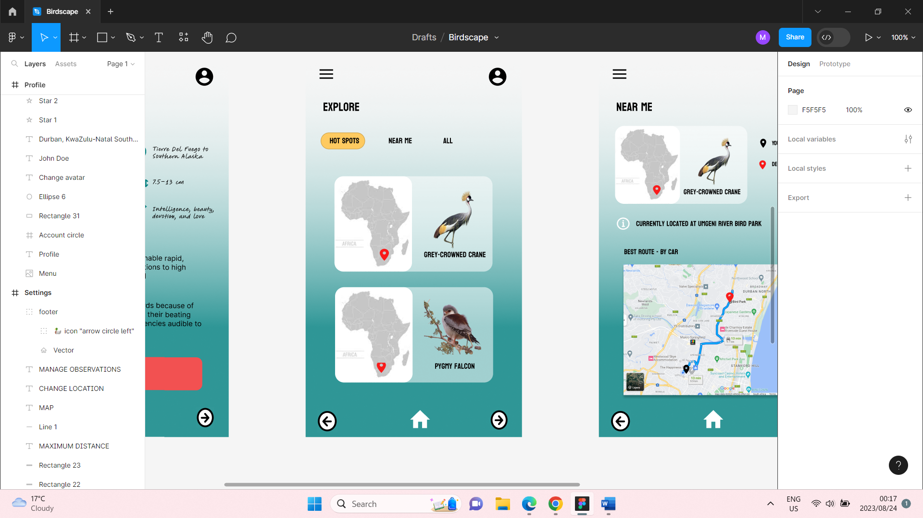

**Near Me**

“Near Me” shows information about the animal, as well as a route map to view the bird in-person. Clicking on the map will allow user to save the location, on the next screen.

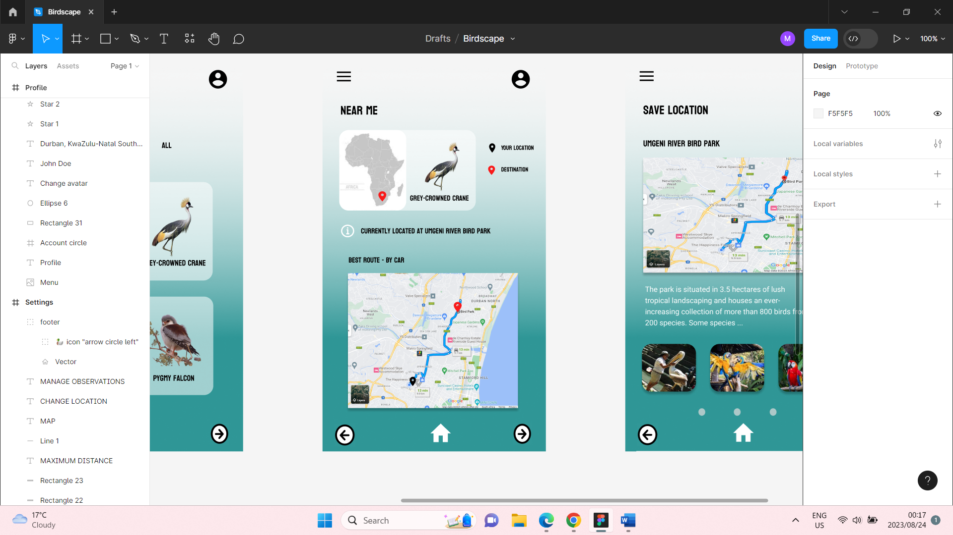

**Save Location**

User is allowed to save the currently viewed bird’s location and images.

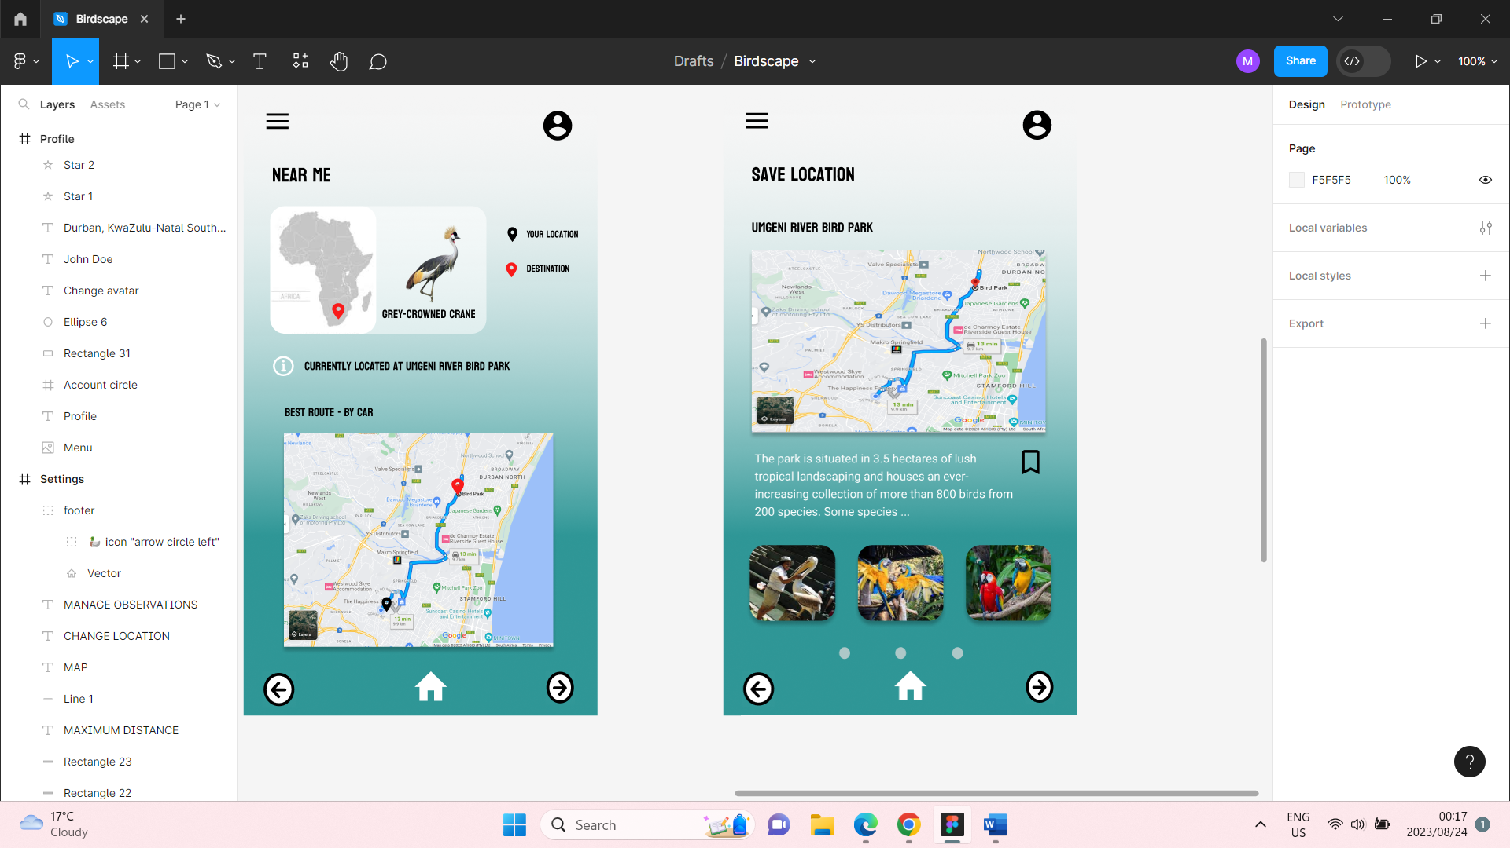

**Observations**

The “Observations” screen lets you view current and past observations.

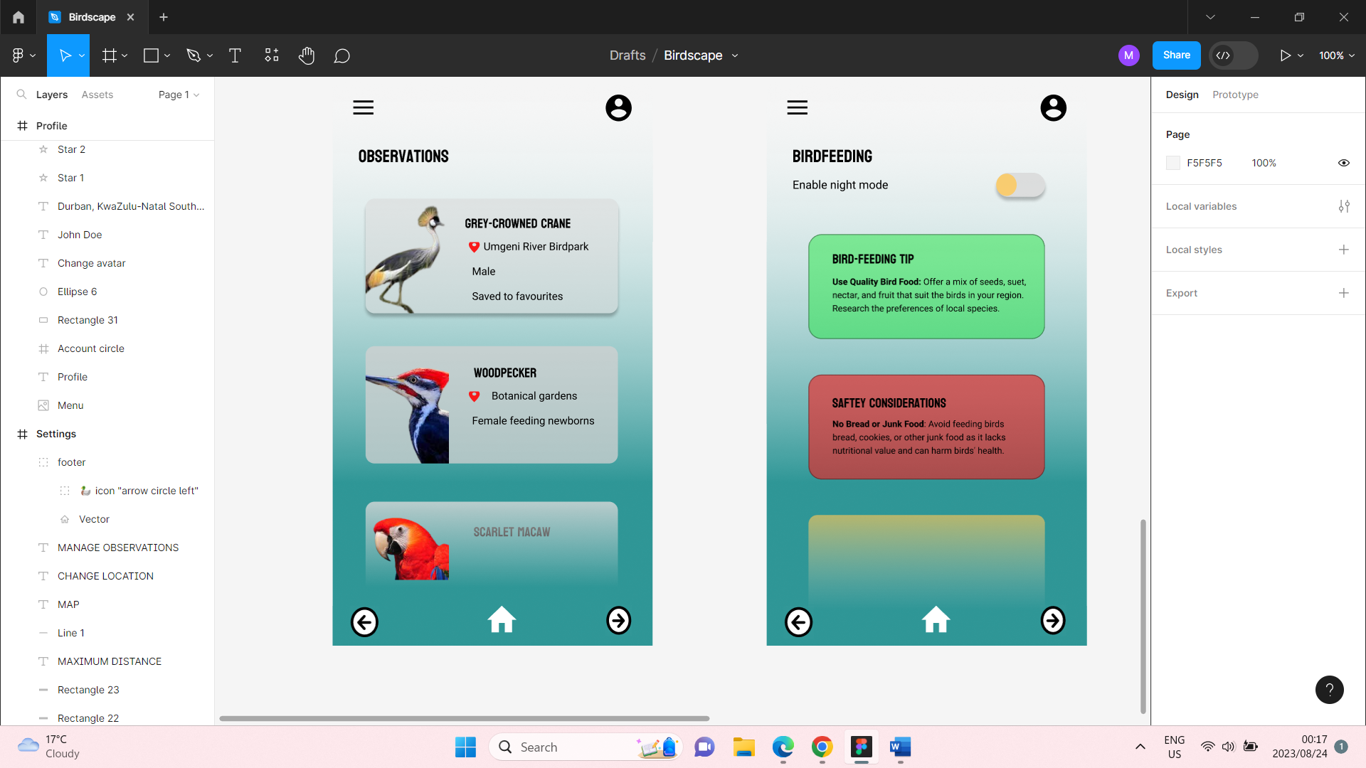

**Bird-Feeding**

This screen gives the user tips and tricks about birds, as well as a night-mode feature.

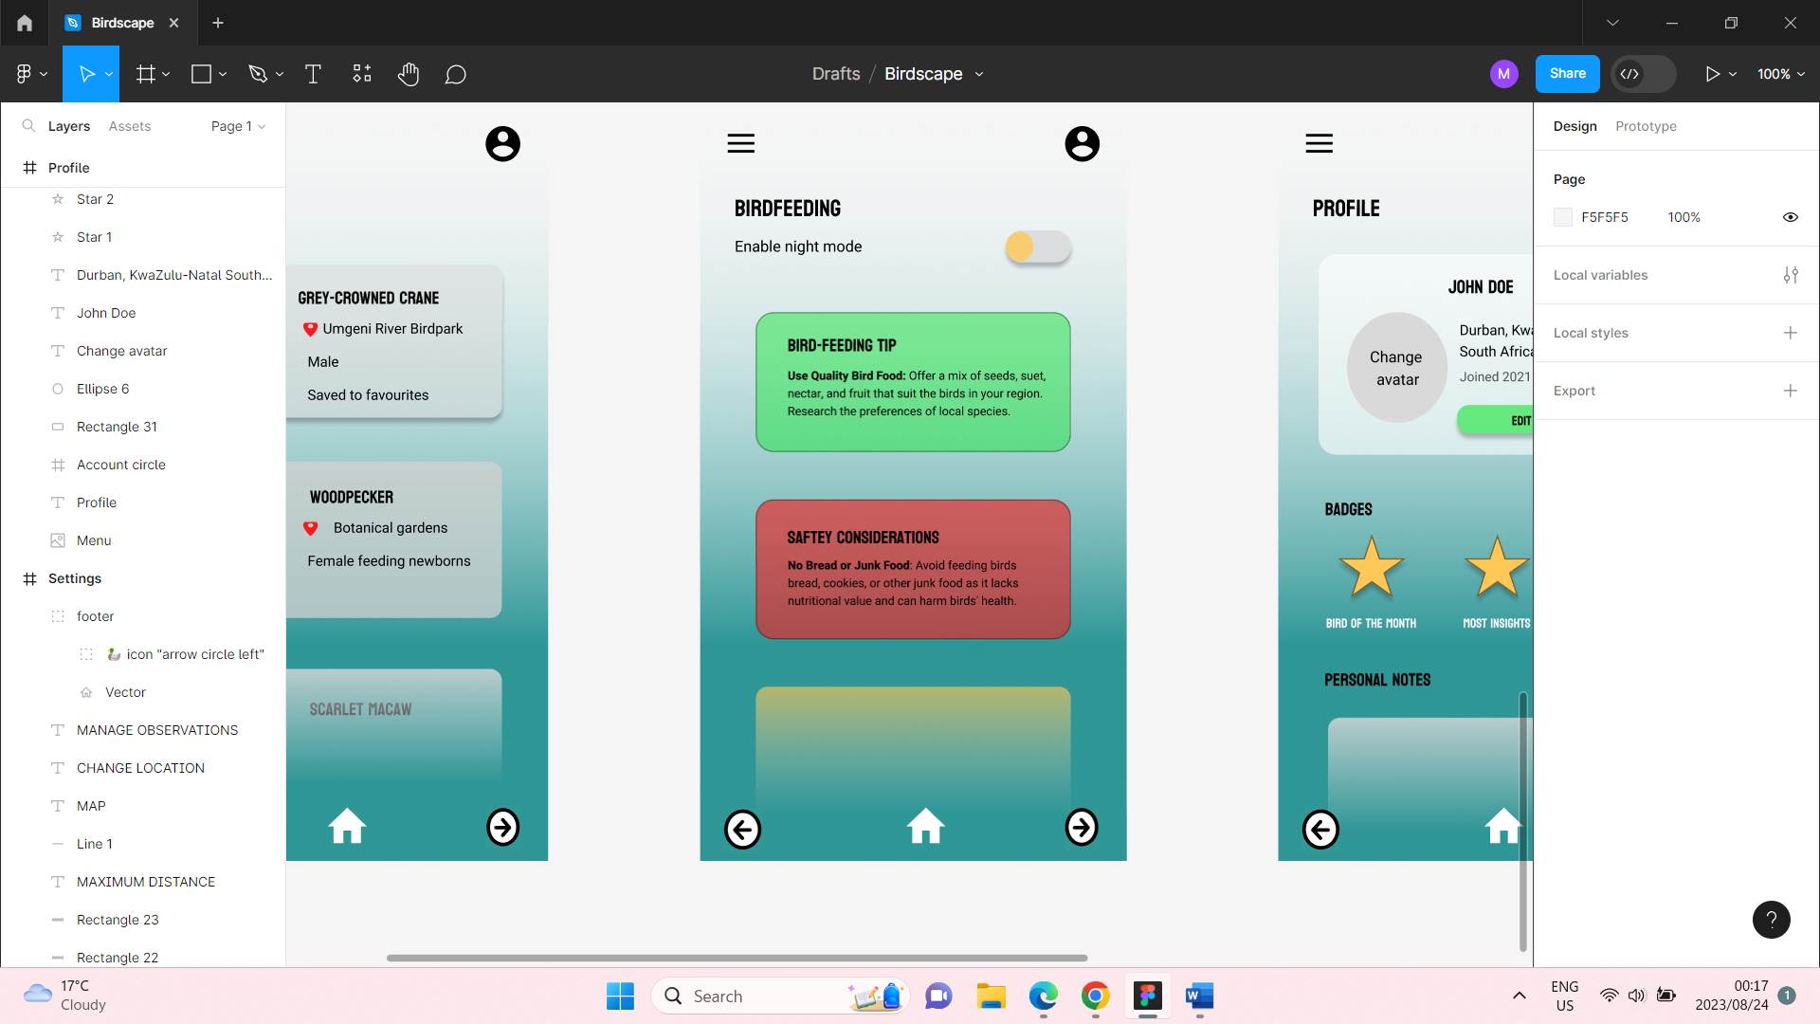

**Profile**

“Profile” shows user profile, allows to change an avatar, add personal notes, and display user badges achieved, from Birdscape.

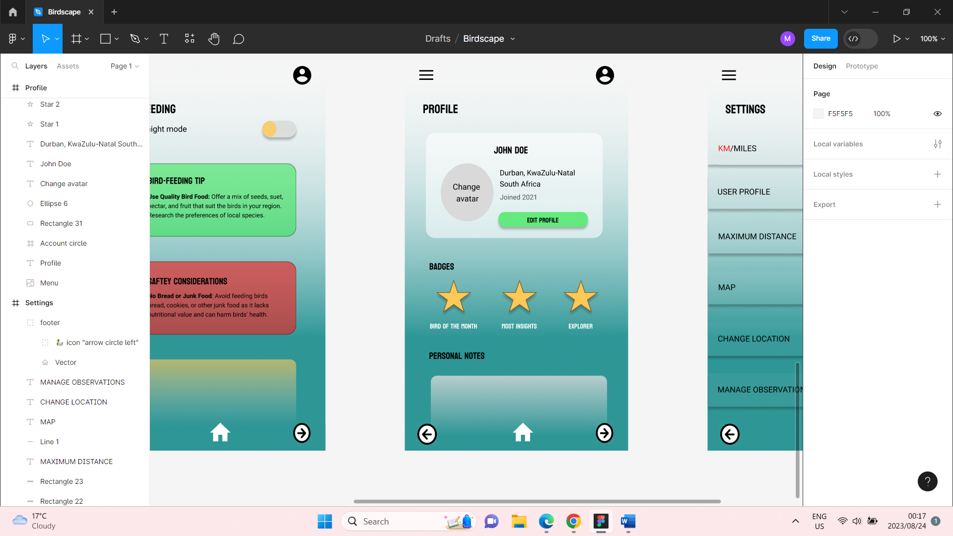

**Settings**

This is the app’s last screen that allows the user to manage their account and the app, in general, through the many available tabs. Also allows user to change distance metric and input their maximum travel distance.

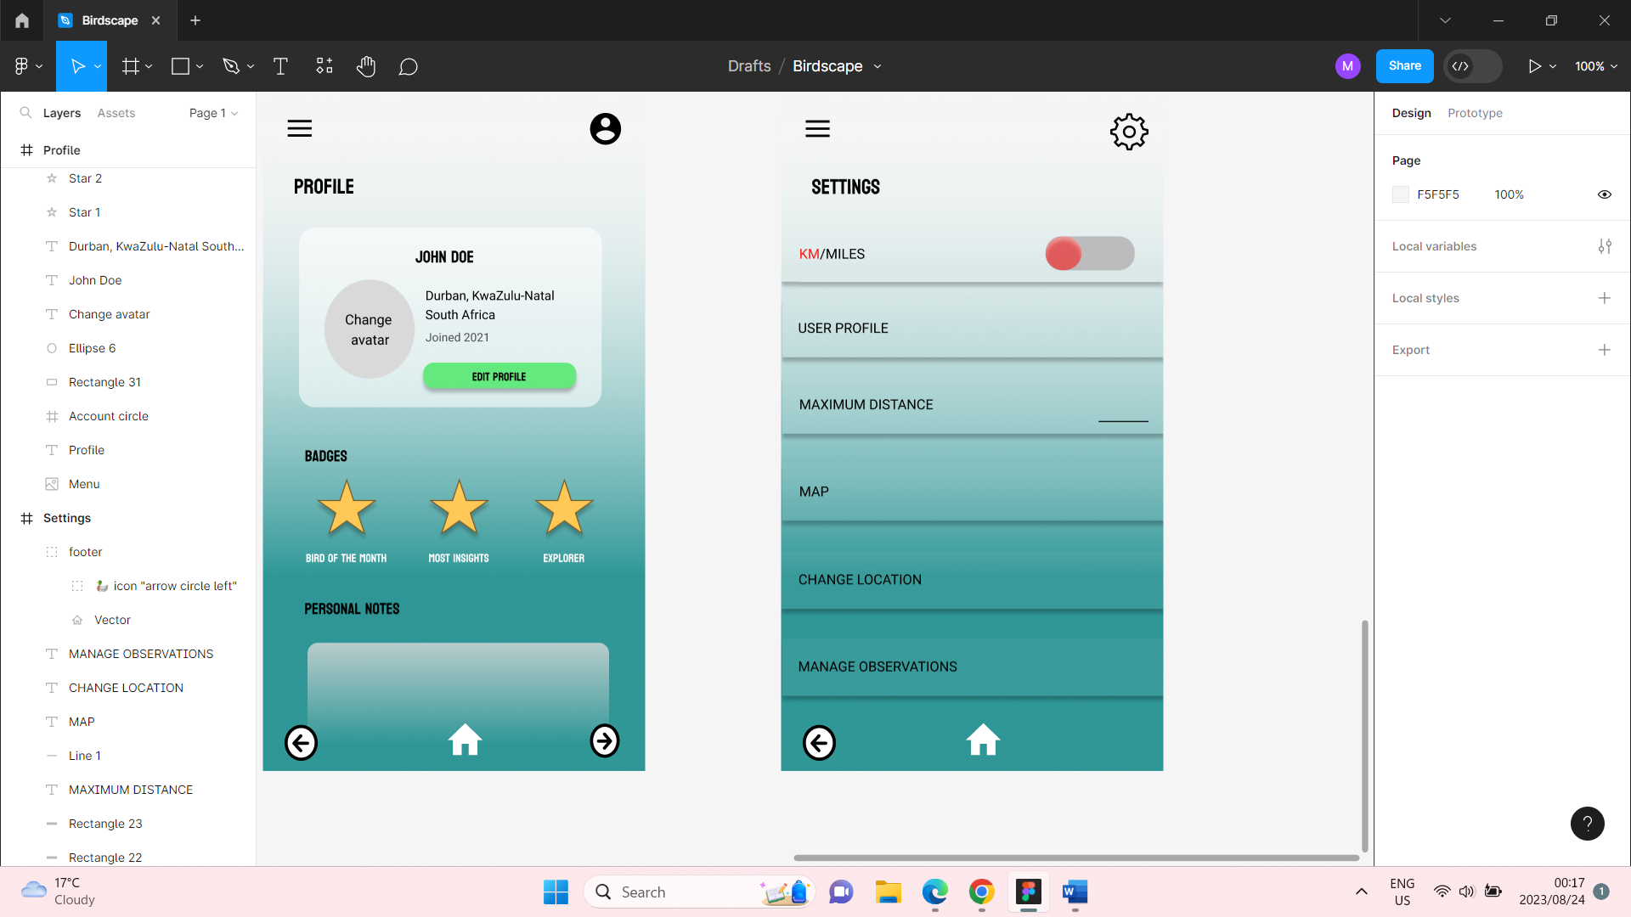

**User Navigation Map**

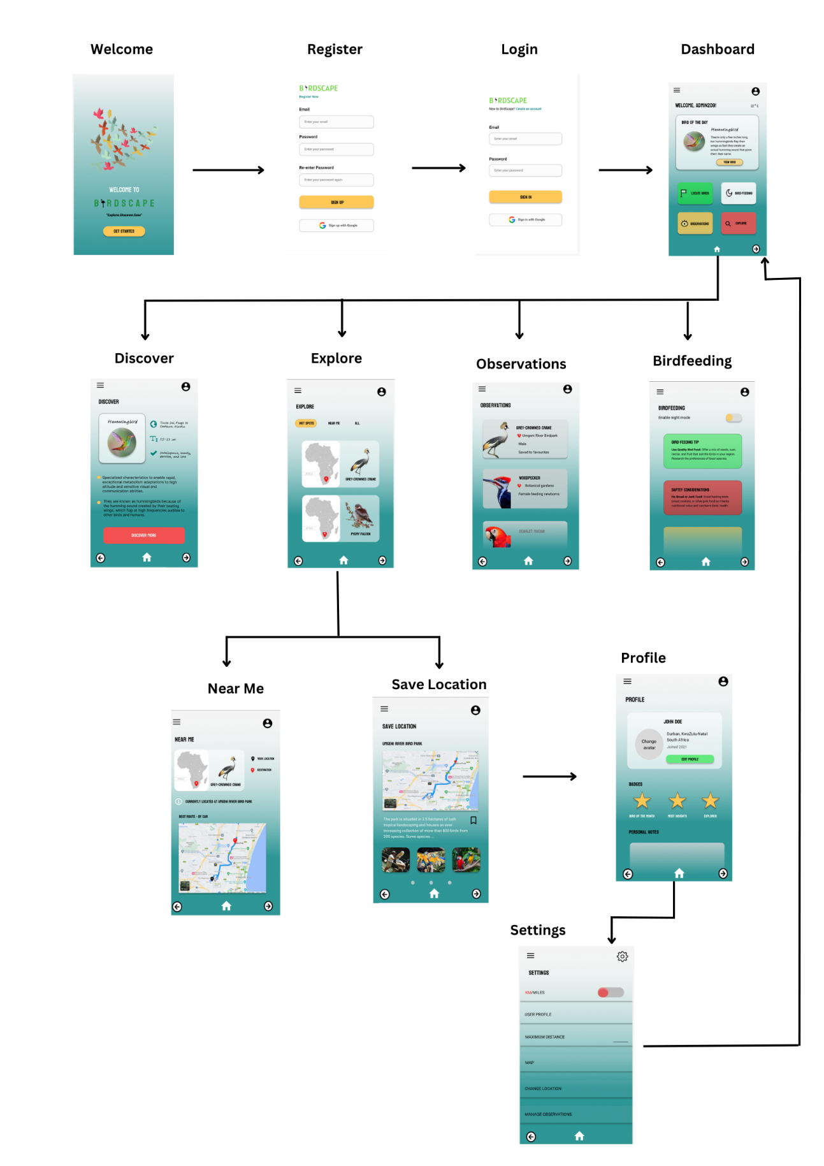

**Detailed Listing of Data**

Data Type List for Birdscape:

User Data:

* Email (String)
* Password (String)

Bird Sighting Data:

* Bird Species (String)
* Date and Time of Sighting (DateTime)
* Location (Latitude, Longitude)
* Notes (Text)
* Images (List of Images)

Map Visualization Data:

* User's Position (Latitude, Longitude)
* Hotspot Markers (List of Coordinates)
* Sighting Markers (List of Coordinates)

App Settings:

* App Theme (Dark/Light)

API Integration:

* Maps API (e.g., Google Maps)
* Location API (e.g., GPS)
* Firebase API

App Analytics:

* User Activity Tracking (Events, Timestamps)

UI/UX Assets:

* Icons (Images)
* Images for Hotspots and Bird Species

Database References:

* Hotspot IDs (Unique Identifiers)
* Bird Sighting IDs (Unique Identifiers)

Location Services:

* Buttons
* Lists
* Maps
* Images

**Project Plan**

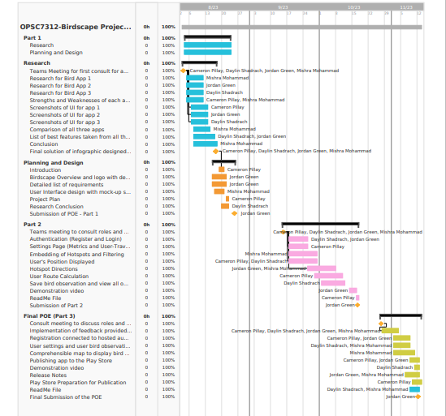

**Conclusion**

In conclusion, the Birdscape app is a complete and user-friendly solution for passionate bird watchers and environmental lovers. Birdwatching, a beloved recreational pastime, takes on new dimensions with the revolutionary features of Birdscape, making it more accessible, instructive, and fun. The app's emphasis on sustainability guarantees that wildlife is not disturbed, which is in keeping with the core of birdwatching.  
  
Birdscape's user-centric design stresses convenience from registration through exploring. Users may easily create accounts, allowing them to access customized experiences. The integration of Google Maps and GPS in the app makes hotspot finding, navigation, and real-time placement easier. The user experience is improved by filtering hotspots based on journey distance. Birdscape's core feature is the ability to record and display bird observations, allowing users to document their interactions, dig into species information, and relive cherished experiences. The inclusion of significant bird news and weather information into the app enriches the whole experience, encouraging both knowledge and responsible exploration. The carefully crafted user interface, which is supported by APIs such as Google Maps and Firebase, enables smooth interaction. The hosted database effectively orchestrates data administration, including user profiles, bird sightings, and preferences.  
  
Birdscape is set to reimagine birdwatching by connecting people with nature, facilitating learning, and supporting environmentally friendly activities. It acts as the perfect companion as users go on adventures to see avian wonders, enabling them to record, explore, and appreciate the diverse world of birdlife.

# **References**

**For API integration:**  
  
Google Maps API. (n.d.). Retrieved from <https://developers.google.com/maps>  
Firebase. (n.d.). Retrieved from <https://firebase.google.com/>

**For App Analytics:**  
  
Mixpanel. (n.d.). Retrieved from <https://mixpanel.com/>  
Google Analytics. (n.d.). Retrieved from <https://analytics.google.com/>  
For Images and Icons:  
  
Iconfinder. (n.d.). Retrieved from <https://www.iconfinder.com/>  
Unsplash. (n.d.). Retrieved from <https://unsplash.com/>  
For Database References:  
  
MongoDB. (n.d.). Retrieved from <https://www.mongodb.com/>  
Microsoft SQL Server. (n.d.). Retrieved from <https://www.microsoft.com/en-us/sql-server>